

Project 3

**Comparative Study of Countries**



A SIMPLILEARN PROJECT

FOR TABLEAU TRAINING

**SUBMITTED BY: Shubham Saxena**

**List of Project Tasks**

1. A geographic map showing countries field. Color the map based on Income column from the secondary data set.

* Include a filter of income group to the dashboard

1. Include a web page to show data from world bank web page driven by an URL action from geography graph.

* The country names in the map will act as the trigger  [https://data.worldbank.org/country/<country>?view=chart](https://data.worldbank.org/country/afghanistan?view=chart)

1. Create a KPI Table to show the comparison between the selected period and the prior period to the selected one.

* Create two parameters for Year Selection and Category Selection.
* Category Parameter to have Life Insurance Share, Market Share, Penetration, Ratio of Reinsurance Accepted & Retention Ratio
* Create a calculated field to calculate the Growth %.
* Create a table to show these values as shown.
* Title to be updated based on the category selection

**PROJECT CREATION**

A geographic map showing countries field. Color the map based on Income column from the secondary data set.

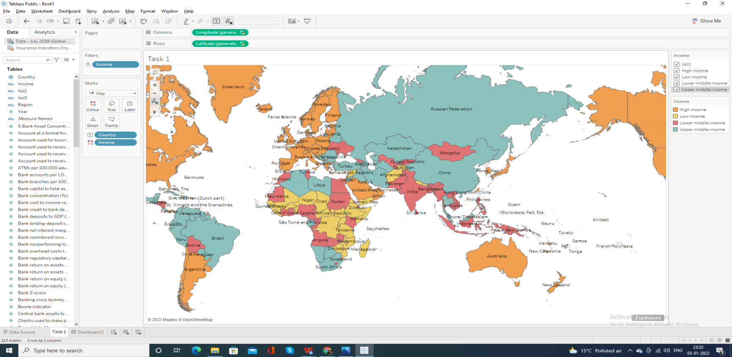

Include a filter of income group to the dashboard

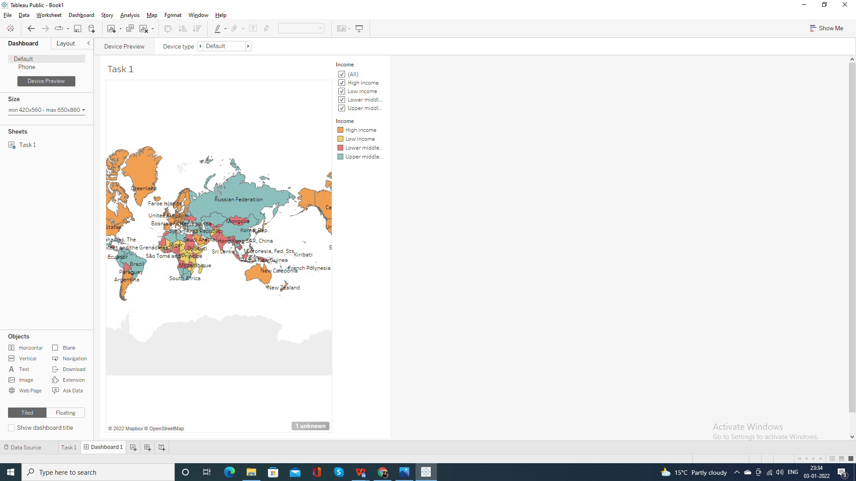

Include a web page to show data from world bank web page driven by an URL action from geography graph

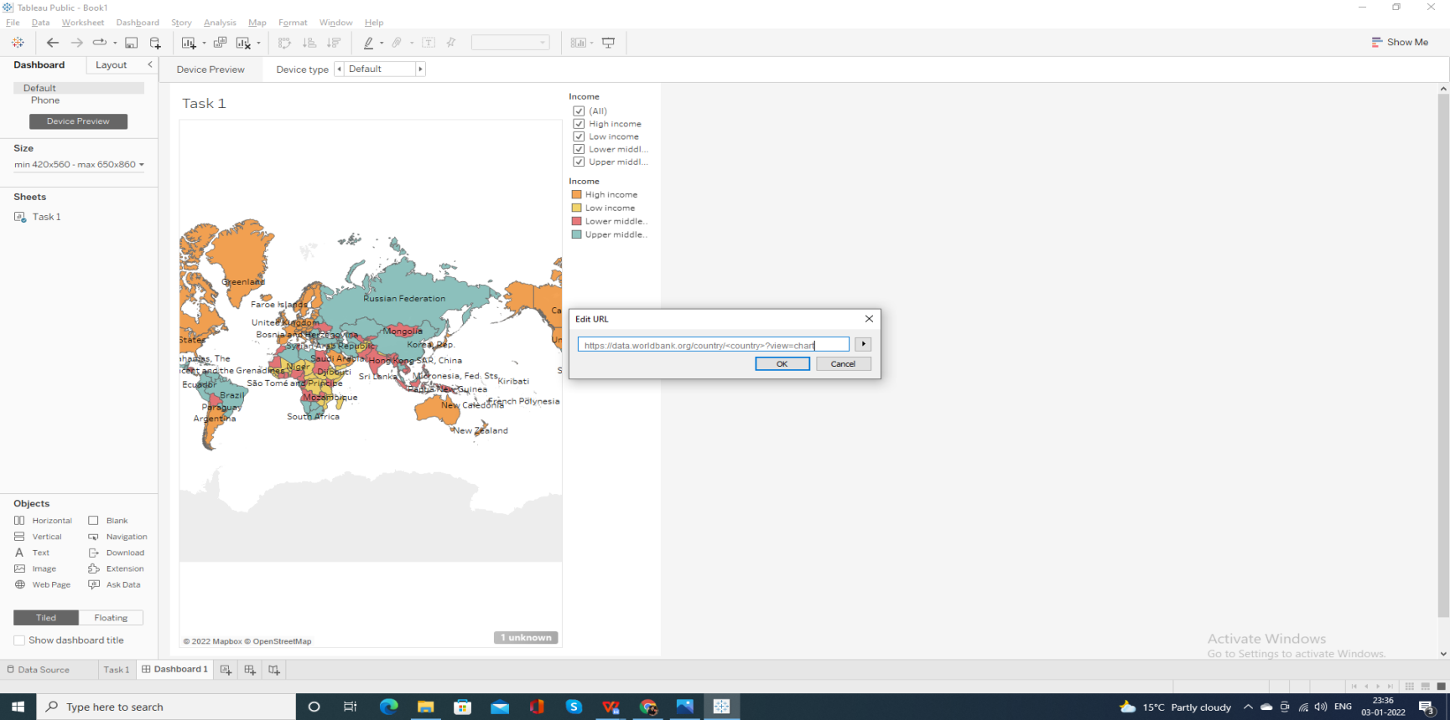

The country names in the map will act as the trigger  [https://data.worldbank.org/country/<country>?view=chart](https://data.worldbank.org/country/afghanistan?view=chart)

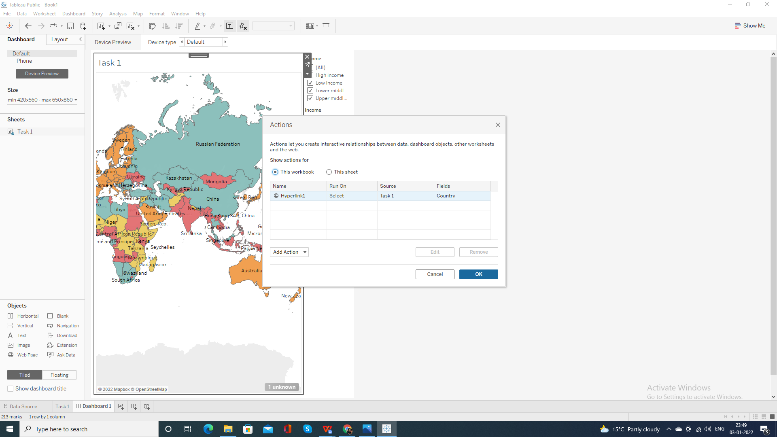

Web Page Linking

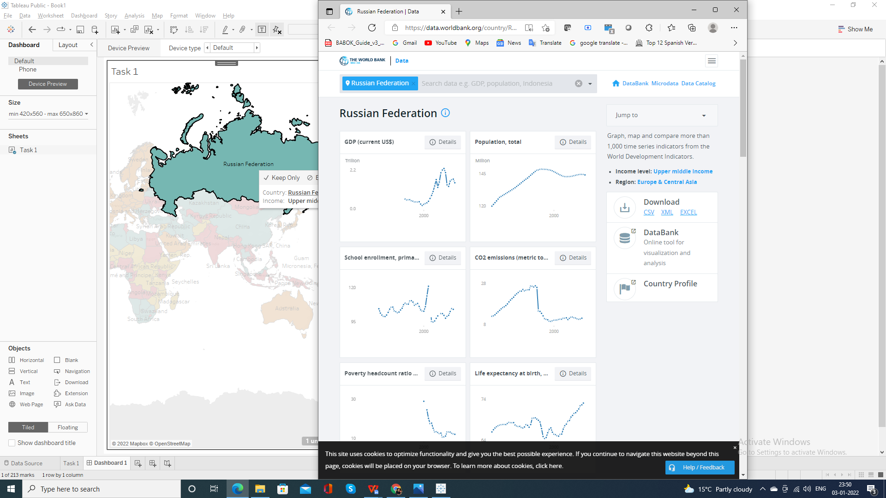

Web Page Linking

